1.

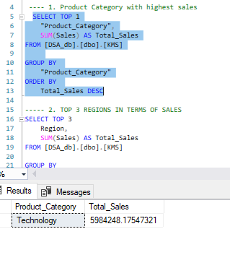

2.

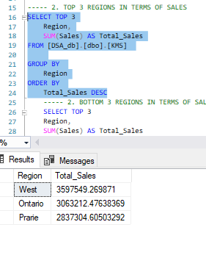

2.

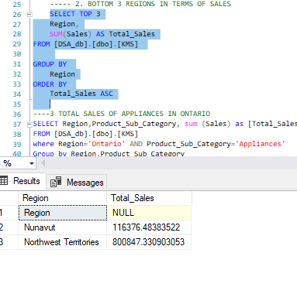

3.

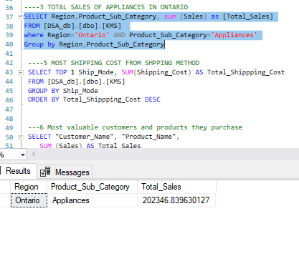

4) **1. Understand their current purchase behavior**

* **Profile their purchases**: Are they buying only low-value or promotional items? Are they limited to specific product categories?
* **Identify barriers**: E.g., budget constraints, lack of awareness of other products, or logistical issues.

**2.Offer targeted promotions**

* Provide **personalized discounts or bundles** on products related to what they already buy, to encourage upselling or cross-selling.
* Launch **“loyalty accelerator” offers**, such as double loyalty points or rewards for the next purchase.

**3.Improve engagement**

* Assign a **dedicated account manager or customer success representative** for business customers.
* Use **email or SMS campaigns** to showcase new products relevant to their interests.

**4.Ensure exceptional service**

* For customers who buy infrequently due to service issues (e.g., delayed deliveries), address those proactively.
* Offer **priority shipping** or **flexible return policies** to build confidence.

**5 Gather direct feedback**

* Run **short surveys or direct calls** to understand what’s preventing them from buying more or buying again.
* Offer a small incentive for completing the survey.

**6️ Expand product awareness**

* If their purchases are concentrated in a narrow range, introduce them to **complementary products**.
* Use **recommendation engines** in online stores or personalized catalogs.

**7️ Set growth goals**

* Create a **revenue growth target** for each of these customers, and monitor their progress quarterly.

5)

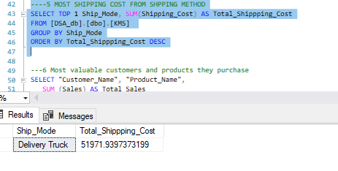

6) 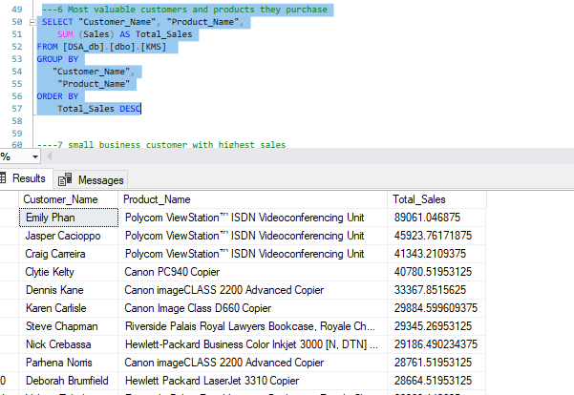

7)

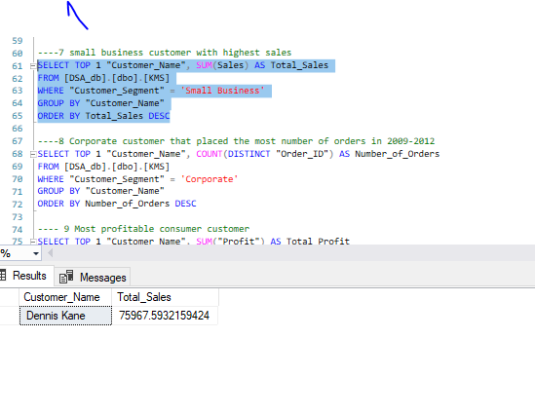

8)

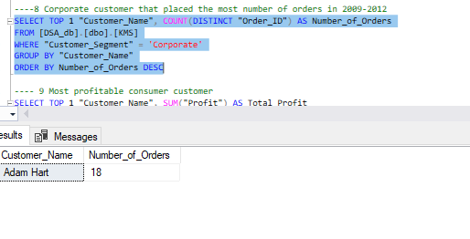

9)

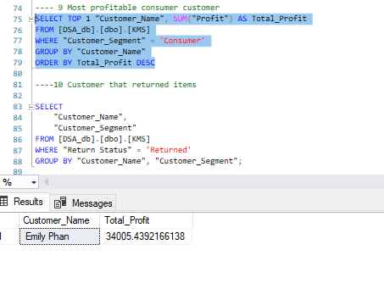

10)

11)

* **Delivery Truck**  
   Most economical (lowest shipping cost)

Slowest shipping time

* **Express Air**  
   Most expensive (highest shipping cost)  
   Fastest shipping time
* **Order Priority**  
  Likely values: High, Medium, Low, Not Specified.

So ideally, you’d expect:

* **High priority orders** → shipped via **Express Air** (to meet urgent needs despite higher cost).
* **Low priority orders** → shipped via **Delivery Truck** (to minimize cost since speed is less critical).

**How to check if spending aligns with order priority**

We would expect:

* The **average shipping cost** to be **higher for high priority orders** (due to Express Air usage), and
* **lower for low priority orders** (due to Delivery Truck usage).

Similarly, you would also want to see that:

* **Most high priority orders** used **Express Air**.
* **Most low priority orders** used **Delivery Truck**.

**✅ A suggested SQL analysis**

You can use a query like this to see **shipping method usage by order priority**, along with the average shipping cost:

sql

CopyEdit

SELECT

"Order Priority",

"Ship Mode",

COUNT(*) AS Number_of_Orders,

AVG("Shipping Cost") AS Avg_Shipping_Cost

FROM sales_table

GROUP BY "Order Priority", "Ship Mode"

ORDER BY "Order Priority", "Ship Mode";

If your data doesn’t have an explicit Shipping Cost field, use total sales or profit impact.

**Conclusion: Is the company spending appropriately?**

I would conclude they are spending appropriately if:

* High priority orders predominantly use **Express Air**, with higher average shipping costs.
* Low priority orders predominantly use **Delivery Truck**, with lower average shipping costs.

If you find the opposite (e.g., low priority orders frequently use Express Air), that’s a sign of **misalignment**, increasing costs unnecessarily.